Drive Mode Control Mirror - CGEA1.3

Functional Description

The purpose of the Drive Mode control mirror is to show the Drive Mode status when the Drive Mode changes. The display will indicate the vehicle’s current Drive Mode status.

This Drive Mode Control Mirror function will use the EOL Configuration input, the cluster Operational_Mode and the DrvPerfMde_D_DsplyHud CAN signal to determine the Drive Mode Control Mirror display.

Interfaces

Interface Context Diagram (I/O Block Diagram)
Figure 1 Drive Mode Control Mirror Interface Context Diagram
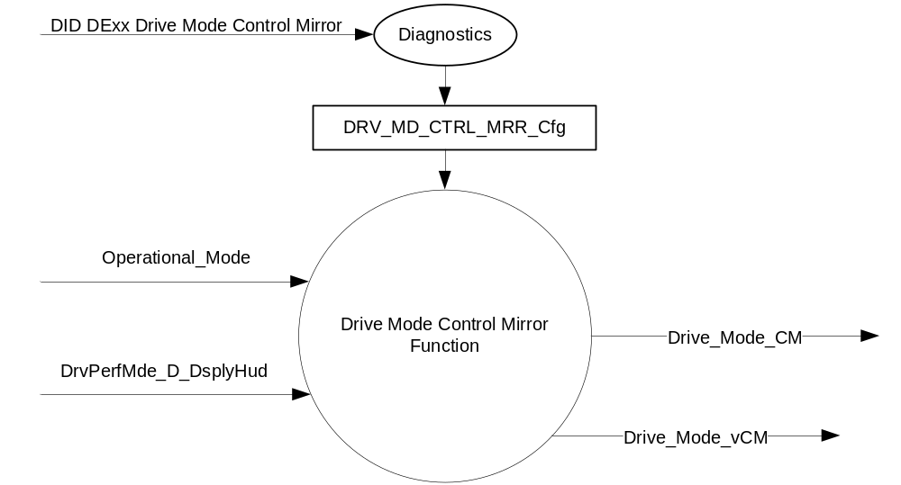

Inputs

      - INTERNAL:
- Operational_Mode
- DRV_MD_CTRL_MRR_Cfg
- MUX signal that the IPC transmits on the CAN Bus

- Input Signals
Signal Name | Size (bits) | Detail | Units | Res. | Offset | State Encoded | Min | Max
DrvPerfMde_D_DsplyHud | 2 |  | SED | 1 | 0 |  | 0x0 | 0x3
DrvPerfMde_D_DsplyHud |  | None |  |  |  | 0x0
DrvPerfMde_D_DsplyHud |  | Sport |  |  |  | 0x1
DrvPerfMde_D_DsplyHud |  | Comfort |  |  |  | 0x2
DrvPerfMde_D_DsplyHud |  | Not used |  |  |  | 0x3

Outputs
- Drive_Mode_CM (used to control the state of the Drive Mode Control Mirror Display)
- Drive_Mode_vCM (used to indicate the variable state of the Drive Mode Control Mirror Display)

Function/Performance

Operational Modes

Mode | Differentiating Vehicle Conditions
Sleep Mode | Drive Mode Mode Control Mirror OFF
Limited Mode | Drive Mode Mode Control Mirror OFF
Normal Mode | Drive Mode Mode Control Mirror ON/OFF
Crank Mode | Drive Mode Mode Control Mirror ON/OFF

Voltage Levels

Refer to the Features table located in Operational Modes and Voltage Range Strategies Section in this SPSS.

Human-Machine Interface

Visual

Indicator Graphics / Display Format

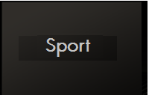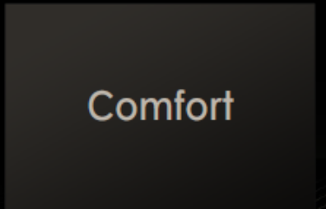
Drive_Mode_vCM = 0x1 (Sport) Drive_Mode_vCM = 0x2 (Comfort)

Above are example graphics.
Actual graphics are to be provided by Ford HMI or Studio and approved by the DI Application for each program.

Audio

None.

System Accuracy

The state matrix in 1.3.5.1 shall be executed within 100msec of a state change of the DrvPerfMde_D_DsplyHud signal.

Operation: Performance and Functional

Subsystem Algorithm Flowchart / State Diagram

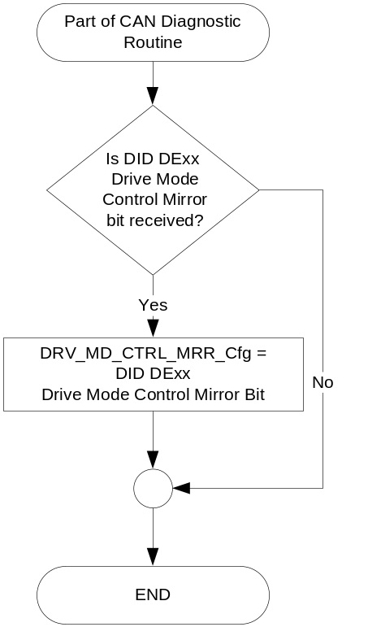

- State Matrix for Drive_Mode_CM
Operational_Mode | DRIVE_MODE_CTRL_MRR_Cfg | DrvPerfMde_D_DsplyHud Signal | Drive_Mode_CM | Drive_Mode_vCM
Normal or  Crank | Enabled | 0x0 (None) | 0x0 (Inactive) | 0x0 (No Display)
Normal or  Crank | Enabled | Transition to 0x1 (Sport) | 0x1 (Active) | 0x1 (Sport)
Normal or  Crank | Enabled | 0x1 (Sport) | No change | 0x1 (Sport)
Normal or  Crank | Enabled | Transition to 0x2 (Comfort) | 0x1 (Active) | 0x2 (Comfort)
Normal or  Crank | Enabled | 0x2 (Comfort) | No Change | 0x2 (Comfort)
All Other Cases |  |  | 0x0 (Inactive) | 0x0 (No Display)

Operation Description (supports algorithm flowchart /state diagram)

The HMI logic specified in the cluster display logic STSS shall define when to trigger the Drive Mode control mirror popups, which should be based upon a request to be displayed.

The logic specified in the Control Mirror Arbitrator STSS shall define the timeout of the popup and any arbitration for requesting the display of the popup, which should be based upon a change in the value of Drive_Mode_CM.

The cluster display logic STSS shall specify the display arbitration when an AHUD is present in the vehicle.

The program specific graphics corresponding to the value of Drive_Mode_CM and its location in the cluster shall be provided by Ford HMI or Studio and approved by the DI Application for each program.

Function Safety Classification (EMC)

B

Memory Storage

Parameter Name | Description | Value at  Battery Connect | Value at  Module Wake-up
DRIVE_MODE_CTRL_MRR_Cfg | EOL Configuration to enable Drive Mode Control Mirror display in the IPC. | Use stored value | Use stored value
Drive_Mode_CM | Indicates the state of the Drive Mode Control Mirror display | 0x0 (Inactive) | 0x0 (Inactive)
Drive_Mode_vCM | Indicates the variable state of the Drive Mode Control Mirror display | 0x0 (No Display) | 0x0 (No Display)
Operational_Mode | 4 state indicator for HUD operational mode | Limited | Limited, Normal or Crank
DrvPerfMde_D_DsplyHud Signal | CAN signal from IPC | See CCD Control Function w Adaptive Drive - CGEA1.3 | See CCD Control Function w Adaptive Drive - CGEA1.3

Error Handling

Missing Message Strategy

There are no DTCs associated with this feature since all of the inputs are internal to the IPC.

Diagnostics

Self Test

None

Engineering Test Mode

Reference section “Dealer / Engineering Test Mode (ETM)”

Part II Performance

Supported Diagnostic Trouble Codes (DTCs)

No DTCs shall be logged for this feature.

DID DExx
Bits | State: Description | "0" | "1" | Default | Comments/  Information
1 | Drive Mode Control Mirror | Disabled | Enabled | Enabled
*Byte and bit location to be identified in Part II Specification for this cluster

Reference Specification

- CCD Control Function w Adaptive Drive - CGEA1.3
- Control Mirror Arbitrator – CGEA1.3
- Appropriate Message Center Display STSS
- Appropriate Program Specific Text Translation File
- Appropriate Program Specific IPC Menu Structure File
- Appropriate Program Specific Wallpapers

Revision History

SPSS Module Revision History

Revision Level | Name | Change Description | Date
1.0 | T. Cwik | Initial Release for review | 8/15/2014
2.0 | T. Cwik | Update of Drive_Mode_CM state definitions to be common with other XXX_CM variables.  Section 1.3.5.1 - Table 1.1 – For Drive_Mode_CM, change 0x3 (No Display) to 0x0 (No Display) in two places  Section 1.3.5.2 – Updated STSS references in Sections 1.3.5.2.1, 1.3.5.2.2 and 1.3.5.2.3.  Section 1.3.5.4 – For Drive_Mode_CM, change 0x3 (No Display) to 0x0 (No Display) in two places  Section 1.6 – Changed the first reference to Control Mirror Arbitrator – CGEA1.3 | 8/20/2014
3.0 | T. Cwik | Updated to be compatible with the Control Mirror Arbitrator Logic STSS where there is a two state variable for each Control Mirror item.  Section 1.2.1 – Figure 1 – Added Drive_Mode_vCM  Section 1.2.3 – Added Drive_Mode_vCM  Section 1.3.3.1.1 added “_Value” in 2 places  Section 1.3.5.1 – Table 1.1 – Updated the Output Columns  Section 1.3.5.2.1 – Rewritten  Section 1.3.5.2.2 – Rewritten  Section 1.3.5.2.3 -- Rewritten  Section 1.3.5.4 – Added Drive_Mode_vCM  Section 1.6 -- Rewritten | 8/27/2014
3.1 | T. Cwik | Update to correct logic and typo errors cited during Visteon review.  Section 1.3.5.1.– Table 1.1 – Added two rows and changed two rows where DrvPerfMde_D_DsplyHud column contains 0x1(Sport) or 0x2 (Comfort).  Section 1.3.5.2.1 – Changed “Dimming Interior Illumination” to “Drive Mode” | 2/19/2015

